Waroud Al Ahmad – Accountant and business owner,
  - Lebanon
Woroud Al Ahmad, a successful accountant and trainer, lives in the Bekaa Valley area in eastern Lebanon. She is one of the estimated 10 – 15 per cent of the Lebanese population who has a disability. This group of people experience widespread discrimination, marginalisation and exclusion. Moreover, women and girls with disabilities in Lebanon experience double discrimination in realising their rights, due to inequalities based on both gender and disability. Policy-makers in Lebanon often think of disability from a charitable or medical perspective, instead of taking a rights-based approach and seeing people with disabilities as wanting to work and contribute to their communities.
Woroud has faced a number of barriers throughout her life, but one of the biggest has been other people’s attitudes. “When I was a little girl, they called me ‘limp’ and they throw stones at me. I always hear the phrase: You are un-useful. But I'm not a helpless woman. I can be a wife, a mother. I said to myself, I have cerebral palsy but I'll make it, and prove to all people that I am strong.”
Woroud has been connected with the Lebanese Union of People with Physical Disability (LUPD), the Disabled People’s Organisation (DPO) in her area, for many years. Through the DPO, she has been able to complete vocational training in accounting. She excelled at her studies, and wanted to use her new skills to join the workforce.
Since 2017, LUPD has been working as part of a consortium of in-country partners, including Oxfam, CARE and Makhzoumi Foundation, to implement a livelihoods project in Lebanon. The project is supported by the Australian Government, and it provides apprenticeship and on-the-job training opportunities to young Lebanese. In 2018 Woroud was selected to take up a four-month apprenticeship as an accountant within a business in Bekaa as part of this project. She spent time
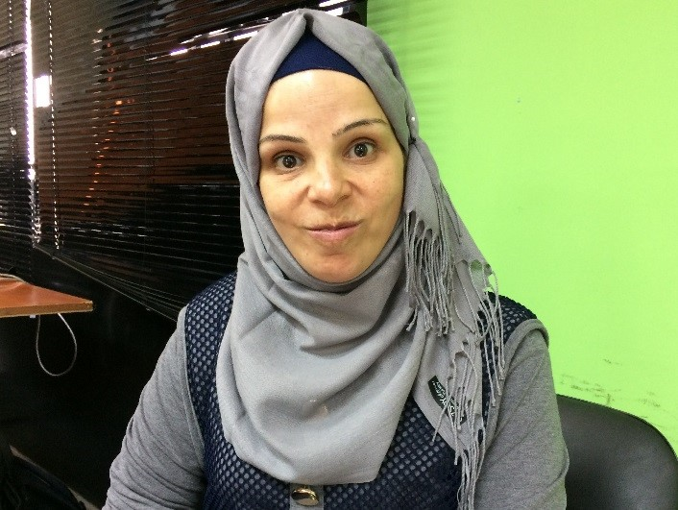 “I said to myself, I have cerebral palsy but I'll make it, and prove to all people that I am strong.” - Woroud
©Elizabeth Morgan, CBM Australia
learning on the job where she built her skills in accounting, including learning to use software programs. Through Woroud’s apprenticeship, she was referred by the audit centre where she worked to support accounting audits in other businesses in the Bekaa area. She is now working within a different business to build an accounting software system for them.
Woroud’s skills and abilities have also led to her becoming an Assistant Trainer for an intensive vocational course, through which a group of people with disabilities was trained in using accounting software. Woroud’s real-life experiences helped her facilitate the 60-hour training course.
In August 2018, Woroud was selected to attend a disability inclusion workshop for international NGOs in Beirut. This workshop was co-facilitated by the Lebanese Union of People with Physical Disability and CBM Australia, and hosted by Oxfam in Lebanon. Woroud participated in a session in which people with disabilities shared their life experiences and recommendations for improving disability inclusion in livelihoods projects in Lebanon. The workshop participants appreciated Woroud’s powerful words, which drew on her strong determination to work and contribute to her community, and her lived experience as a woman with disability who has become a successful accountant, trainer and advocate.
Now, after completing a Marketing and Management course, Woroud has taken the initiative to prepare a feasibility study for a collective business with other colleagues. She plans to launch a small ’one dollar shop’, and was recently successful in applying for a grant to support her plans. Woroud has a lot of experience in trading and can draw on her accounting experiences to help her start up her own business and achieve success. She is a strong role model for women with disabilities: “My disability is not a barrier that prevents me go ahead with my life”.

