Savina NONGEBATU – deputy chief exective officer, Pacific disability forum (PDf)
  - Solomon islands
Savina Nongebatu has spent many years as an advocate and leader for disability rights, “working to change people’s minds and hearts about disability” both in her home of Solomon Islands and across the Pacific. Approximately 60,000 Solomon Islanders have a disability.
Savina was born in the Gizo in the Choiseul and Western Provinces, a rural island in the west of Solomon Islands. At six years of age, she moved to the capital, Honiara, with her family. There she went to school, got married, had children and started her working life as a public servant. Savina was living a typical urban life in Solomon Islands.
In 2000, at 31 years of age, Savina went in to hospital for an operation on her spine. Following her operation, Savina acquired a physical impairment and became a wheelchair user. Savina recalls spending three years in her home after the operation. She stopped engaging with her community. Her mobility was limited due to inaccessible infrastructure. People began to see her differently, attitudes of her friends changed and she was made redundant from her job on medical grounds. Savina describes acquiring a disability as a “new life altogether” for her.
At the time of the operation, Savina didn’t yet know people with disabilities had the right to access opportunities on an equal basis as others. She learned about her rights as a person with disability from the local community based rehabilitation (CBR) co-ordinator who would visit her. This knowledge about disability rights, along with the encouragement of the CBR co-ordinator and support of her family, motivated Savina to become involved in advocating for the rights of other Solomon Islanders with disabilities. Savina started volunteering at the national Disabled People’s Organisation, Persons with Disability Solomon Islands (PWDSI) as the first female president from
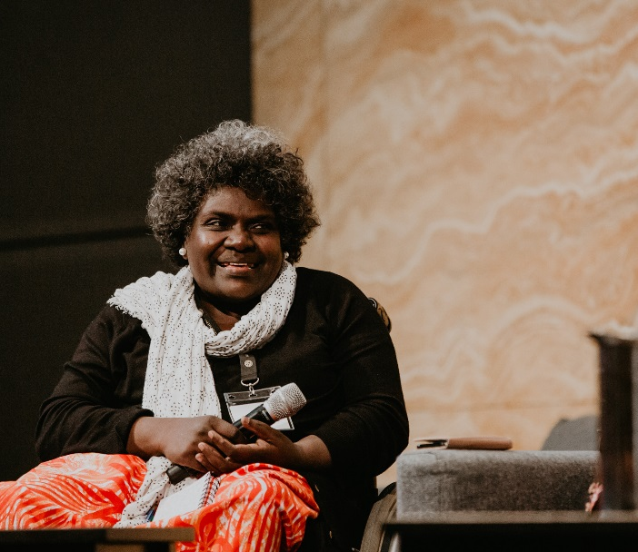
“I am just one person on the continuum of people, working to change people’s minds and hearts about disability.” – Savina
©ACFID Conference
2004-2011, advocating to communities, government and donors to ensure programs became inclusive and people with disabilities had the same opportunities for participation as others.
Savina describes how people with disabilities in Solomon Islands often experience discrimination and stigma, with limited access to community life and the built environment. This discrimination is more pronounced for women with disabilities who have less access to work than men, and are often excluded from decision-making processes. “Being born with a disability can be seen as a bad omen, and so people with disabilities are often discriminated against.” During her many years of working for PWDSI, Savina has observed significant change in attitudes towards disability. Advocacy to both Government and to the community has helped to improve awareness about the rights of people with disability. People have really “warmed up”, Savina says.
In 2018, after 5 years of working for the PWDSI as an office manager, Savina was appointed to the position of Deputy Chief Executive Officer of the Pacific Disability Forum (PDF). As the regional peak body for DPOs in the Pacific Region, Savina will represent and advocate for the rights of people with disability from across the Pacific region with a particular focus on gender and a Deaf situational analysis. Savina feels that this new role will be a great learning experience for her, both personally and professionally as she relocates to Suva, Fiji.
Despite all her years as a champion for disability rights in the Pacific, Savina doesn’t see herself as a leader:
“I am just an advocate for the rights of people with disability, standing on the shoulders of the pioneers who have laid the foundations for this work. I am just one person on the continuum of people, working to change people’s minds and hearts about disability.”
Good support from her family and from PWDSI has allowed Savina to remain engaged in her work. What drives her though, is her passion to see something change for the next generation of people with disabilities.
Savina is grateful to DFAT for their support as a funder of the Pacific Disability Forum (PDF), through which PDF are able to provide support to DPO members across the Pacific. DFAT’s partnerships with CBM and International Disability Alliance have further enhanced the support available to PDF and DPOs in the Pacific. This work has been invaluable in helping to increase awareness on disability rights and improve DPO capacity. Savina describes DFAT and CBM as a “friend to many” DPOs in the Pacific.

