cRECENCIA mADEIRA DE dEUS – dIRECTOR, kLIBUR dEFISIENSIA tILUN (kdtl)
  - tIMOR-lESTEa
Crecencia was born deaf to a large hearing family in 1996. At the age of three when the East Timorese Crisis began, Crecencia was sent away with her older sister to hide elsewhere. This was because Crecencia was considered too noisy due to her deafness and the family was worried she would reveal their hiding place to the militants. Crecencia and her sister developed a close bond, which carries through to today, with her sister now one of two recognised sign language interpreters in Dili.
Crecencia went to a mainstream school but did not learn much in the classroom due to not having access to any information in sign language and a lack of classroom aids. She learned how to read and write some basic English and Tetum from her friends and her sister. When Crecencia was 15, she learned about Agape School for the Deaf in Dili, a school run by missionaries from the Philippines. Deaf students at the school were taught how to sign and learned their lessons in Filipino Sign Language. Crecencia began to attend, learned how to sign and made friends.
After finishing school, Crecencia continued to meet with the friends she made at Agape. In early 2018, this group decided to form a Deaf Association with the support of the peak Disabled People’s Organisation (DPO) in Dili - Associação Dentaria de Timor-Leste (ADTL). They felt that the existing DPOs in Timor-Leste did not accurately represent and therefore advocate for the interests and needs of Deaf Timorese people. KDTL were able to register their organisation in late 2018 with support from ADTL, the interpreters in Dili and the Australia–Timor-Leste Partnership for Human Development (PHD) (funded by DFAT). Part of PHD, the delivery mechanism for Australia's development assistance in Timor-Leste, includes targeted and tailored support for Deaf-specific capacity building activities to KDTL and the Deaf community in Timor-Leste.
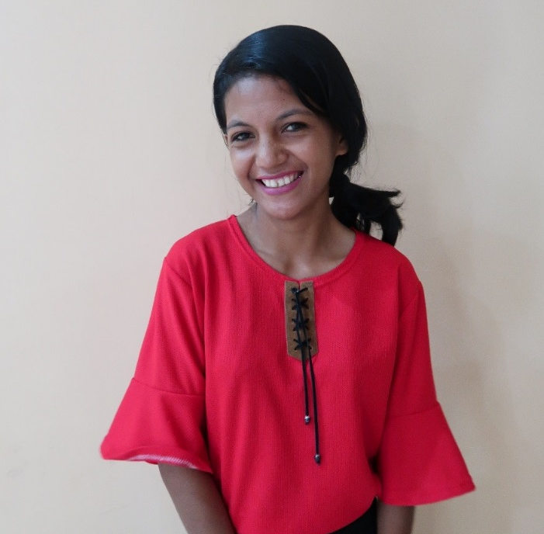
“I want all Deaf children to sign and have an education” – Crecencia.
©Jen Blyth, CBM Australia
The members of KDTL elected Crecencia as Director, because she was seen as a ‘strong and willing leader’. In her role, Crecencia has advocated for KDTL to lead the development of a National Timorese Sign Language and for an interpreter for the television news broadcast. KDTL has had several successful meetings with the Government of Timor-Leste and the need for the development of a National Sign Language is documented in official policies.
Crecencia’s dreams for KDTL and Timor-Leste include all deaf people using Timorese Sign Language, an early intervention program for deaf children and their families across Timor-Leste and acceptance and understanding from all hearing people in Timor-Leste. The support provided to develop and operate KDTL is significant in recognising the capacity of Deaf people in Timor-Leste and allows them to see progress towards the realisation of their goals.

