Risnawati Utami – CRPD Committee Member and disability rights organisation founder
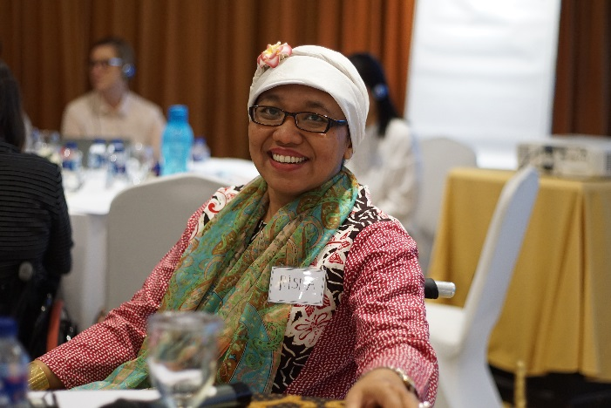
  - Indonesia
Risnawati Utami is a powerful example and voice for the rights of people with disabilities, both within Indonesia and internationally. Risna is the founder and executive director of Ohana, a disability rights organisation based in Yogyakarta. She is Indonesia’s first elected member to the UN Committee on the Rights of Persons with Disabilities, and will sit on the committee for 2019-22.
Risna contracted polio at four years of age, and since then has used a wheelchair for mobility. Her parents supported her to go to school and then on to university, but it took some time for her father to fully accept Risna’s disability. Her father allowed Risna to attend school, but other than that, she had to stay at home and was not permitted to socialise.
“In Indonesia … it is very critical to have strong leadership amongst women with disability” – Risna. ©World Bank
Risna’s father changed his attitude when she was invited by UNESCAP to participate in training in Bangkok on universal design and disability concepts in 2000. This was in the early stages of promotion and development of universal design and accessibility standards in South East Asia and the Pacific. Risna’s father realised that if his daughter was recognised by an international organisation and her community and invited to participate in such events, she must be a strong woman.
Risna’s passion for disability rights developed out of her own experiences of discrimination. When studying to qualify as a lawyer her college was inaccessible, so Risna had to climb the stairs every day to her classes, usually held on the fourth floor. It was Risna’s determination that saw her continue attending classes and gain her qualification.
Risna then experienced challenges gaining employment as a lawyer, explaining that as a woman with disability, she faced stigma and discrimination. After three years of unemployment, she decided it was time to move on and become a disability rights activist. Risna joined an NGO working in disability rights advocacy and for six years managed a “very impressive program” working for the sexual and reproductive rights of women and girls with disabilities. This was an issue she herself faced as a woman with disability. During this time, she published a book about reproductive and sexual health for women and girls with disabilities, and presented at a conference in San Francisco.
Believing that “education can change my life”, Risna applied for and was awarded a Ford Foundation Fellowship in 2005, which enabled her to complete a Master’s degree in International Health Policy and Management at Brandeis University, USA.
In 2012, Risna founded Ohana Indonesia, a disability rights based organisation in Yogyakarta. Ohana has received DFAT funding both through the Disability Rights Fund (DRF) to develop as an organisation and for specific projects, and via a direct grant from the Australian Embassy in Indonesia in 2016-17.
The Australian Embassy grant enabled Ohana Indonesia to develop good practices in line with Article 20 of the United Nations Convention on the Rights of Persons with Disabilities (CRPD) (States Parties shall take effective measures to ensure personal mobility with the greatest possible independence for persons with disabilities). This work was an important starting-point for engaging with the disability rights movement.
The funding from DFAT enabled Ohana to engage with local district government together with local Disabled People’s Organisations (DPOs) to deliver training on personal mobility and establishing local community-based wheelchair shops for livelihood opportunities. Risna explains: “I am a wheelchair user and very passionate on working on wheelchairs. Once I had access to start using a wheelchair, I was able to be more independent in terms of mobility”.
To date, six district governments have each signed a contract with Ohana to work with DPOs, allied health professionals and local governments to provide training and facilitate establishment of wheelchair shops in their district, with two contracts pending. The interest has been not just in Jakarta, but across Indonesia including Bali, Sulawesi, East Nusa Tenggara and Borneo Kalimantan.
The DRF and DFAT funding also enabled Ohana representatives to attend BRIDGE training, a joint initiative of the International Disability Alliance (IDA) and the International Disability and Development Consortium (IDDC) to develop their understanding and work around the CRPD and the Sustainable Development Goals (SDGs). This has enabled Ohana staff to translate the CRPD and SDGs into national and local action. DRF and DFAT funding has at the same time led to increased Indonesian government inclusion of DPOs in implementing policies on the SDGs and the CRPD.
Risna’s involvement in international work around disability rights has also given her the opportunity to participate in multiple Conference of States Parties to the CRPD (COSP) meetings over the past six years, which was made possible through IDA and CBM’s advocacy for greater participation of people with disabilities in COSP meetings. Risna acted as an observer, spoke at side events and as a keynote speaker in the Civil Society Organisation forum, and co-facilitated focus group discussions.
The Indonesian government recognised Risna’s engagement in these different fora as a sign of her leadership, and considered her an influence for good practice. They nominated Risna as a CRPD committee member, and she was elected in June 2018, which she described as “a big deal for me as a woman with disability, especially from Indonesia and the global south”. She sees this as a great opportunity to influence many areas of disability advocacy in Indonesia, in particular the Disability Policy and its implementation in terms of the CRPD.
Looking to the future, Risna acknowledges that there is still progress needed to articulate and implement human rights law at a local level in many countries. This is something she sees as important to address in her role on the Committee. At the district and village level, there is work to be done on understanding of national and international human rights law. She sees one part of the strategy for taking this forward as international cooperation, as per DFAT’s support for the work in Indonesia towards CRPD implementation on the ground. Risna believes that DFAT does important work on policy and good practice in countries like Indonesia, to make the rights of people with disabilities real.
Going forward with Ohana Indonesia, Risna would like to further develop strong leadership amongst women with disabilities in Indonesia. Risna explained that this will be challenging, as women with disabilities in Indonesia experience multiple disadvantages resulting from the interplay between gender, disability and poverty. But it is a challenge that Ohana and Risna are excited to overcome for the future of girls and women with disabilities.

